5 RANGER | o7

MG Cadre

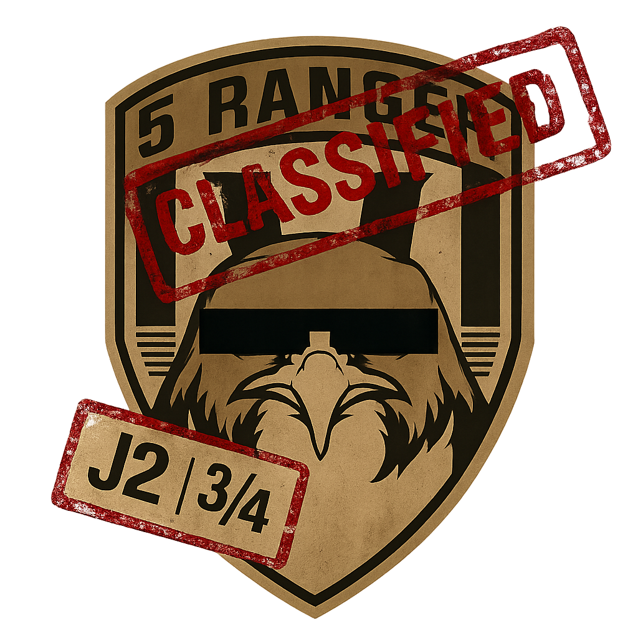

Table of Contents:
5 RANGER | J7 1
MG Cadre 1
Table of Contents: 2
Learning Goals 3
Instructors notes: 3
What will be taught: 3
Teaching Phases: 3
Phase I: Introductions 4
Basic Gunnery: 4
Role of a Section Gunner: 4
Weapons: 4
Ammunition: 5
Other equipment: 5
Linking Munitions & sustaining a fight. 6
Munitions: 6
Weapon Temp: 6
Cooling your weapon: 6
Malfunctions: 7
Phase II: Practicals 7
Suppression: 7
Drill: 7
Talking Guns: 8
Using Talking guns: 8
Drill: 8
Phase III Gun Teams: 9
Drill: 9
Post Cadre: 10
For instructors: 10

Learning Goals

What will be taught:
- Introductions to the gunner role
- Equipment
- Maintenance
- Fire drills

All of these combined will provide an indepth look into the role and capability that a gunner fills within 5 Ranger.

Teaching Phases:
- Phase I:
The 1st phase of the cadre will be focused on introductions to the role, equipment and capability of a section / FST Gunner .
- Phase II:
The 2nd phase of the cadre will be focused on suppression drills against a live force to give opportunity to go over conservation of munitions, Types of suppression and why we use it. Lift/Shift, Cease
This is also a good place to reinforce jamming & Overheating.
The second part will showcase 2 MMGs working in conjunction in the form of “Talking” guns.
- Phase III:
A final exercise bringing all parts together.
The instructor will go over gun teams, what they are, why they can be useful, when they can be useful and how to use them. They will also go over the role and responsibility of each person in the gunteam.

Equipment:

Instructors to ensure that each player has the following:
- 400rnd tracer ammunition
- 1 Spare barrel
- 1 Canteen
1 GPMG or L110 MMG

A template Gunner kit can be acquired from the default ‘public’ loadouts.

Phase I: Introductions

Firepower is a core tactical function, whose role is to fix the enemy in order to enable manoeuvre, not to destroy in isolation .
We can reinforce this at section level by repeatedly stressing fire discipline, arcs, and controlled application of fire, rather than volume alone .

Basic Gunnery:
This section will cover the basic equipment of a Section gunner within 5RB to include:
- MMG / GPMG
- Ammunition
- Spare Barrels
- Canteens

Role of a Section Gunner:
A section Gunner provides fire by volume to a fire fight. Suppressing an enemy in place through the weight of fire. A section gunner aids in pinning and denying freedom to the enemy, whilst allowing safer movement to friendly forces.
- FIX is a prerequisite to STRIKE and EXPLOIT; machine guns are the primary fixing tool in close battle .
- Fieldcraft Manual Lesson 20 & 24: cadets must “obey fire control orders and understand fire discipline” — the gunner is the embodiment of that discipline .
“The gunner does not win the fight alone — he holds the enemy in place so others can.”

Weapons (GPMG vs L110)
New weapon segment (MiniMe vs M240B)
A section Gunner has two choices of weapon:
- The L7a1 General Purpose Machine Gun (GPMG)
Comes with an inbuilt bipod, a longer barrel and fixed stock. Its advantage is its higher rate of fire and accuracy, its downfall is the lack of optics and its weight.

- The L110a3 7.62 Medium Machine Gun (MMG)
Originally adopted for use by Paratroop and marine forces the L110 has a rail system for optics and accessories. It is also shorter, making it far more ideal for multi purpose warfare or in cases where movement will be more common. It however does have a lower rate of fire and is more inaccurate when compared to the L7a1.

As such both have their place, the choice becomes which is the right tool for the mission at hand.
- Economy of effort — weapons are chosen to suit the mission, not preference .
- Fieldcraft Chapter 2 (Organisation & Grouping): fire support assets are grouped to achieve effect, not parity.
Instructor emphasis
- L7/GPMG → sustained, accurate, deliberate fire from prepared positions
- L110/MMG → mobility, integration with manoeuvre, flexibility

Ammunition, Load & Sustainment
The section gunner has access to three types of belts:
- The 100rnd 7.62 belt
- The 100rnd 7.62 Tracer Belt
- The 200rnd 7.62 Tracer belt
It is required that Gunners take 100rnd belts as these take up less weight, and are linkable.

Other equipment:
A section gunner carries a spare barrel for their main weapon. When the weapon begins to overheat, this will cause malfunctions. Swapping the barrel prevents this during long engagements. Another way to cool the weapon is with the use of a Canteen.

In addition, the Section gunner carries all other regular infantry rifleman equipment.

- SUSTAINABILITY — combat power must be preserved over time .
- Tracer is a fire control and observation tool
- Ammunition is finite; poor discipline collapses fire plans
Add section about pressing C for bipod

Linking Munitions & sustaining a fight.
This section will cover: Linking ammunition belts, Checking Weapon Temp, Cooling your weapon with a canteen, Swapping barrels and malfunctions.

Linking belts:
Linking ammunition to your weapon is often faster and more efficient than reloading outright.
This will link 100 rounds of additional ammunition to your current ammunition count.
This will not work if you're using the 200 rnd Boxes, your assistant can check by looking at your ammo. Do not use the 200 rnd boxes, they are for vehicles.

To do this:
ACE self interact: Ctrl+ WIN > Equipment > Link ammunition

Weapon Temp:
Gunners have a bit more admin than other regular roles, the more sustained fire they put down in a short period, the more heat will build up in a weapon.

This is split into 4 conditions: split into 12 lines:
- GREEN - Line 1-3, weapon is cool, no chance for a malfunction
- YELLOW - Line 4-6 Weapon is warm, little to no chance for malfunction
- AMBER - Line 7-9 Weapon is hot, moderate to high chance to malfunction
- RED - Line 10-12 Weapon is overheating, will jam consistently

You can check this by ACE self interacting:
Ctrl + WIN > Equipment > Check weapon Temp

Cooling your weapon:
Keeping your weapon cool is vital to avoid malfunction. As such gunners should keep a half eye on their weapon temp.

There are two ways to cool your weapon.

- Replace the Barrel
ACE Self Interact:
Ctrl + WIN > Equipment > Swap Barrel
This will bring down the temperature substantially and put the hot barrel into your backpack.
It takes time for the hot barrel to cool down. Barrels can be found in Misc.
- The Canteen
ACE Self Interact:
Ctrl + WIN > Equipment > Use canteen
A gunner can cool the weapon by pouring out their canteen onto the weapon, this will bring down the weapons temp by a good margin, however it will consume most of the canteen contents and may need multiple applications.

Malfunctions:
The hotter the weapon the more prone to malfunction it becomes.
When the weapon jams do not panic.
To clear the weapon use the following keybind: Shift + R by default. Once done a short animation will play and a box will appear to let you know the weapon is clear.

Weapon Temperature, Barrels & Malfunctions
- Weapon stoppages are a predictable friction, and can be avoids
- Stress equipment care as a continuous responsibility.
- Heat is managed through fire control, not reaction
- Barrel swaps and cooling are tactical actions, not technical chores

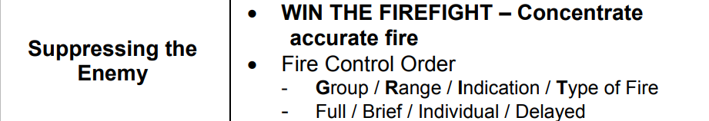

Phase II: Practicals

Definitions

Fire Unit. This is any number of cadets firing under one commander, the fire unit commander, e.g. fire team, and the fire team commander.

Fire Direction Orders. These are orders that a fire unit commander receives from their superior. They may include key ranges, special orders to withhold fire, when to open fire, at what targets and at what rates.

Fire Control Orders (FCO). These are orders that the fire unit commander gives to control and direct the fire of their cadets.

Arc of Fire. This is the ground for which a fire unit is responsible and in which it engages targets.

Axis of Arc of Fire. This is the approximate centre of the arc.

Field of Fire. This is the area of ground on which an individual cadet or fire unit can fire effectively.

Suppression (Deliberate vs Rapid Fire)
Suppression is a vital tool during combat operations, denying the enemy observation, movement, and decision-making and is centred around the gunners ability to lay down fire.

control of fire is essential to maintaining tempo and initiative .

Deliberate Fire
For a Gunner this is a 1 second burst every 3-5 seconds.

Used for laying down a slow but consistent volume of fire to the enemy whilst conserving ammunition.
- Sustained, controlled fire aligns with economy of effort and sustainability .
- Fieldcraft FCO lessons emphasise cadence and observation over continuous firing .
“Deliberate fire is the default state of the gun.”

Rapid Fire
For a Gunner this is a 1 Second Burst every 2nd second.
Providing an intense volume of fire at the cost of munitions expenditure
- rapid fire is used to gain or regain fire superiority, not maintain it indefinitely .
Instructor emphasis
- Short duration
- Command-driven
- Ammunition expensive

Lift, Shift, and Cease Fire

Drill:

Player will conduct the following 2 drills:
Drill 1:
- Suppress a group of enemies using only deliberate fire.
- This will be concluded when the belt runs empty
Drill 2:
- Suppress a group of enemies using only rapid fire
- This will be concluded when the belt runs empty

Talking Guns:
Talking guns is the act of 2 or more weapons operating in tandem with one another to lay down a constant rate of fire whilst splitting the ammo load between multiple guns. As such the more guns involved in talking, the less ammunition each gun will use.
A lead gun will begin by firing a burst, and when completed, a second gun will immediately take over. They will go back and forth like this until one gun runs out of ammunition. The other gun will then fire longer sustained bursts until it is back in the fight.

Communication is vital: call when you are reloading, that your gun is down etc.
Talking guns can cover a large area alone with ease and will minimize the amount of ammunition consumed in suppressing a target.

Establish diagrams/examples on overlapping and interlocking arcs directly underpin talking guns .

Highlight co-operation and concentration of force — achieved here through timing, not mass .

Continuous effect, not continuous firing

Communication sustains pressure

Drill:
Two of the players will lay down and set up their guns.
They will then suppress and eliminate a group of infantry using talking guns.

This will continue until both gunners have reloaded twice.

Phase III: Gun Teams

Gun Team Concept
A gunteam is a group of soldiers working on one system, usually 2 or three people. The Gunner operates the weapon, whilst the Assistant gunner provides him security, links his ammunition and keeps the weapon cool.
The assistant gunner can do this by ACE interacting with the weapon:
This will give you the following options:
- Check weapon temperature
- Check ammunition
- Link ammunition (if the user has fired ammunition out of it)
- Swap barrel

“A good assistant keeps the gun firing.
A great assistant keeps it effective.”

- Assistant gunner enables freedom of action for the gunner by managing friction (ammo, heat, observation) .
- Fieldcraft observation and indication lessons justify the assistant’s role in calling arcs, ranges, and threats .
- Stress mutual understanding and trust under Mission Command .
- Reinforce two-person systems minimum for security, observation, and sustainment .

Sustained Defence
This will allow a gun team to keep a MMG in operation for longer periods as the gunner can focus on engaging the enemy, whilst the assistant, calls out ranges, bearings and keeps the weapon operational .

Standard procedure is that an assistant should always inform the gunner before replacing their barrel, call out weapon temps and call when linking more ammunition to the gunner.

Done correctly, this means that the only thing bringing your gun out of the fight will be, swapping barrels or a lack of ammunition.

- Stress endurance, fire discipline, and avoiding burnout during prolonged contact .
- The gun that remains effective longest usually decides the fight .
- Logistics, communication, and discipline decide outcomes
- The drill proves the value of teamwork under pressure

Drill:
Players will split off into one or more gun teams using their prepared loadouts
1 assistant gunner, 1 gunner.

Players will then go through and defend a position against a live enemy, the assistant gunner linking ammunition and keeping the weapon cool for the gunner. They will then swap and redo the drill. In order to showcase and prove the ethacasy to the players

Post Cadre:
- Players will be taken aside for 1-1 feedback and offered mentoring if required.
- Players will provide feedback to the instructor
- Pictures will be taken and the cadre ended.

